**SIX-MONTH PROGRESS REPORT (JANUARY TO JUNE 2025)**

**ON**

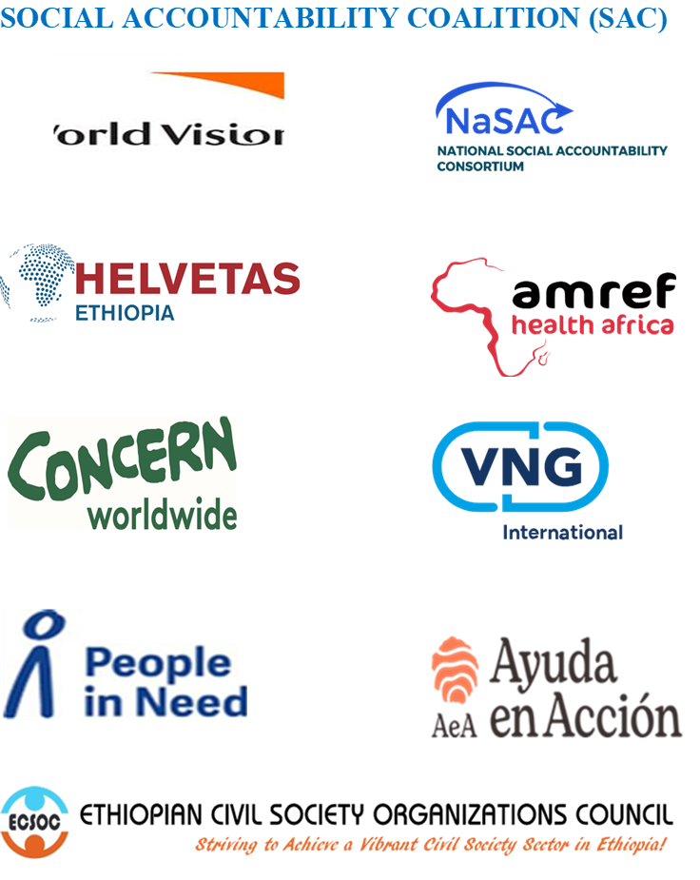

**1 July 2025, Addis Ababa**

**TABLE OF CONTENTS**

**TITLE PAGE**

1. INTRODUCTION 2

2. ESTABLISHMENT PROCESS 2

3. PLANNING 3

4. WORKSHOP 4

5. PROGRAM IMPLEMENTATION 4

6. COMMUNICATION 6

7. CHALLENGES AND SOLUTIONS 6

**SOCIAL ACCOUNTABILITY COALITION (SAC) SIX-MONTH PROGRESS REPORT**

1. **INTRODUCTION**

This semiannual report is written on the journey of the Social Accountability Coalition (SAC), which was established by VNG Int, World Vision Ethiopia, Helvetas Ethiopia,Amref Health Africa, Concern Worldwide, People in Need, Ayuda en Acción, and the two national networks: the Ethiopian Civil Society Organizations Council (ECSOC) and the national Social Accountability Consortium (NaSAC). The report includes data from January to June 2025 for the last six months.

1. **ESTABLISHMENT PROCESS**

29 November 2024, VNG Int. prepared a preliminary discussion on the importance of the Coalition on Social Accountability. In this event, fourteen International INGOs and 16 Local CSOs, as well as seven invited government representatives, attended. All participants agreed to leverage collective efforts to address complex issues of Social Accountability and its sustainability by establishing a coalition.

After the ESAP program was phased down, NaSAC took over coordination and, in collaboration with VNG Int, hosted an official event for MoU signatories on October 31 at the Inter Luxury Hotel. On this day, the MoU, which had been shared with potential signing bodies two weeks earlier, was presented and evaluated.

On this signatory date, there were two challenges, the first one was that half of the invited parties who had given their consent in the first discussion were unable to attend. The second challenge was that though the rest of the attendees admired the effort, they were unable to sign the MoU since they were not in positions of power, but they vowed to persuade their country director of the importance of the SA coalition. So, at the time, the MoU had only been finalized with World Vision, which was a historical milestone, and NaSAC was tasked with knocking on the doors of each interested organization to explain the coalition's relevance.

Following separate conversations with seven INGOs, we were successful in that the seven INGOs signed the MOU

1. **PLANNING**

The strategic plan and the result framework were prepared and shared with all nine signatory bodies to consolidate based on their comments. One virtual meeting was conducted on 21 January 2025 to allow signatory parties to provide feedback on the strategic plan and to discuss upcoming procedures. In that meeting, the Transitional Task Force (TTF) nominated and started its work by aligning key activities of the coalition with the plan and interests of signatory organizations.

Before the validation workshop, which was conducted on 19th March 2025, each signatory body sent their intervention areas in alignment with their own 2025 organization plan with the Coalition Strategic Plan.

1. **WORKSHOP**

The Social Accountability Coalition (SAC) Strategic Plan 2025-2027 Validation Workshop was conducted at Yaden Hotel, Bisheftu on 19TH March, 2025. The main objective of the workshop was to ensure the strategic plan's effectiveness by testing its alignment with the agreed-upon MoU.

In this workshop, high officials from the Authority for Civil Society Organizations, the Ministry of Finance, Federal Civil Service Commission made important speeches in their opening, closing, and keynote speeches about the sustainability of social accountability and the relevance of the Social Accountability Coalition (SAC). Executive Directors of the 26-member CSOs of the National Social Accountability Consortium (NaSAC) also participated in the workshop.

In this validation workshop, four papers were presented by experienced professionals, and an in-depth discussion was held with the participants. The details are found in the validation workshop report.

1. **PROGRAM IMPLEMENTATION**

Except for People in Need and World Vision, the rest of the signatory parties prepared their intervention plan in the coalition to consolidate NaSAC and ECSOC. However, due to the USAID stop work policy except Helvetas, all are not in apposition to implement their plan. Even Helvetas supports only the technical part, which does not cost.

In terms of technical support, Helvetas Ethiopia, Concern world Wide, VNG Int, and Ayuda en Acción have visited SAC’s and NaSAC’s coordination office through their focal representatives and gave their advisory services in terms of resource mobilization, strategic planning and network management.

Helvetas Ethiopia not only visited the coordination office but also assigned three professionals who can support SAC and NaSAC either virtually or physically in terms of Office Automation, Digital Data tracking System on public Service Delivery, and Partnership. Helvetas also linked the SAC with other National and International coalitions and other CSOs.

VNG Int visited our office three times and donated around 34,000 USD as seed money to NaSAC. Additionally, VNG Int linked SAC with other International Organizations.

ECSOC visited the coordination office and linked with the Austria Development Agency, World Bank, GIZ, and other prominent professionals who can potentially support the SAC. Additionally, ECSOC linked NaSAC and SAC with UNDP, which resulted in two of our network CSO members being sub-granted to conduct a pilot study on public service delivery in Addis Ababa and the Oromia Region.

People in Need, though, could not have a plan to support SAC in 2025, the program manager and director have given advisory services two times face-to-face and five times via phone conversation. The People in Need also invited NaSAC to attend the localization workshop that was held on 25 June 2025 at the Harmony Hotel.

Though Amref Health Africa shows an interest in supporting SAC during the discussion in their office and validation workshop, they are not giving high attention in practical terms.

The country director and the focal person of Ayuda en Acción are very interested in supporting SAC. The country director gives enough time to listen to SAC's strategic plan and its operation in his office. He assigned one focal person to support SAC. In line with this, the focal person visited the SAC coordination office and gave expert advisory services on resource mobilization and organizational management.

Though World Vision is the pioneer for signing the SAC MoU, it could not plan to support SAC in 2025. Additionally, though the focal person is interested in attending virtual and face-to-face meetings, no one could attend.

NaSAC is striving day and night to make SAC into reality. From coordinating the coalition in patience from the outset till now, NaSAC has cost a lot. For the last six months from the establishment process and after the establishment of SAC, NaSAC covers office and administrative expenses worth around 10,000 USD. NaSAC is also successful in lobbying government authorities to work with SAC through an MOU. Due to increasing its presence, NaSAC can be donated a used Vehicle By ACSO.

The program manager and the focal person of Concern Worldwide took a positive commitment to the initiation and establishment of SAC. The representative visited the SAC office two times and delivered advisory services on strategic leadership and resource mobilization. Additionally, through two virtual and multiple phone calls, the program manager and the focal person supported SAC's progress. However, Concern Worldwide failed to support in terms of financial and material support.

1. **COMMUNICATION**

Communication through email, telephone, virtual, and physical meetings was made with potential and founding members of SAC.

Though the first quarterly meeting made that resulted strategic plan validation workshop at Bisheftu, the second Quarterly Regular Meeting, based on the schedule, could not be conducted due to the majority of members not responding to the virtual meeting schedule.

Individual telephone communication was made with the founding members to tailor their intervention plan to the situation encountered by the USAID

1. **CHALLENGES AND SOLUTIONS**

After initial engagements in meetings, workshops, and signed agreement of the MOU, Except VNG Int., all the founding members of SAC hardly struggle to provide genuine and sustainable support to SAC due to different factors such as a lack of long-term commitment, inadequate understanding of SAC contexts, bureaucratic hurdles in funding mechanisms, lack of confidence of the focal persons to connect with the Country Directors who most probably can able to decide on resources. In this case, the focal persons of World Vision and Amref Health Africa could be taken as an example. Thus, effective communication and coordination are vital to make this coalition its success.

The other challenge is, our office is not only the headquarters of NaSAC but also the coordination office of the coalition; however, the members of the coalition could not say anything about the rent and other coordination expenses. This needs an urgent meeting for a decision

The other big challenge is a lack of a vehicle to coordinate both the coalition and NaSAC. At the end, NaSAC was successful in getting a used car from ACSO. However, this car needs some maintenance and services. This is a critical agenda and needs decisions.

1. **WAY FORWARD**

Considering the specific localization landscape in Ethiopia, the 7 INGOs and the 2 National networks established the coalition on the thematic area of social accountability called the Social Accountability Coalition (SAC). The coalition grounded with the MOU. However, due to a Lack of Long-Term Commitment, Misalignment of Priorities, Complex and bureaucratic funding processes, and other reasons, the SAC members, specifically the INGOs, would not be found on their promise in real terms. This created barriers for member local CSOs to accessing much-needed funds, hindering their ability to implement projects effectively, marginalizing local voices and decision-making processes.

Thus, addressing these challenges requires SAC members to conduct an urgent meeting at a higher level to decide whether the SAC should be strengthened from the perspective of localization or not. We advised INGOs to shift their resources and decision-making power towards more locally-led, participatory, and long-term approaches to international support for civil society. This includes prioritizing local ownership, simplifying funding mechanisms, building genuine partnerships, and fostering a better understanding of local contexts.